LANCASHIRE PLACE NAME SURVEY
Newsletter

December 2017 (Part 1)
www.lpns.org.uk

This edition of the Newsletter is a ‘bumper’ edition and comes in two parts. This is Part 1 - your usual mix of news. Part 2, which will arrive as a separate document, is devoted to an article by our Editor, for the English Place Names Society, Professor John Insley, about the ‘lost’ Lancashire place-name Loxham. I’ve added a postscript to try to place Loxham, based on other documentary evidence (this is at the end of Part 1, so that John’s piece is ‘stand-alone’). John’s piece is a splendid example of his rigorous philology research, and as a pointer to the typical content of the in-preparation ‘major names’ and subsequent hundredal volumes of the Lancashire series.

For the really keen amongst you, it is also going to be published shortly in the journal Namenkundliche Informationen, published by Leipzig University Press, in a Festschrift (celebratory volume) for Albrecht Greule and Dieter Kremer.

But first ….

NEWS AND EVENTS
We welcome Michel Prescott to the LPNS Committee.

Michael’s background is in electronics and amateur radio, and he is passionate about cycling – previously a racer, now a qualified coach, mentor, assessor, and campaigner for Cycling UK. He has been involved in archaeological digs from the Neolithic to the industrial period. He is a member of Lancashire Local Access Forum and Public Rights of Way. There is a 2026 cut-off date for upgrading lost Bridleways which have been designated as footpaths, or not recorded at all. He is working on claiming these using historical evidence, and through this research came across LPNS.
The Regional Heritage Centre at Lancaster University are taking bookings for a study day on Saturday 3 February 2018:
Northern Names – regional aspects of the names of places and people
which will take place from 10.00 till 16.00 in Management School Lecture Theatre 3 at Lancaster University. I can vouch for the new venue being very plush and comfortable.

Speakers including (LPNS’s own) Dr Fiona Edmonds (Director, Regional Heritage Centre) and Peter Iles (Lancashire Archaeological Advisory Service), talking about the progress of the Lancashire Place Names Survey. Dr Eleanor Rye (Institute for Name-Studies, University of Nottingham) will talk about ‘Exploring language and dialect in North-West England through minor place-names’, Angus Winchester (Emeritus Professor of Local and Landscape History, Lancaster University) will speak on field names in the Lake District, and Dr George Redmonds (author of A Dictionary of Yorkshire Surnames (Watkins, 2015)) on ‘Every Tom, Dick and Harry: the significance of personal names’.

The event costs £26 (£23.40 for Friends and Patrons of the Centre) (fee includes coffee/tea & biscuits).
On Saturdays free parking is available on campus.

Programme: http://www.lancaster.ac.uk/users/rhc/events/details/2018/Northern%20Names.html
Bookings: http://www.lancaster.ac.uk/users/rhc/events/details/2018/Northern%20Names.html

The Regional Heritage Centre have also just announced this week that 28 April 2018 will see their Director’s Event:
Cymry in the North: the North Britons from the sixth century to the tenth
This will be held in conjunction with the Cumberland and Westmorland Antiquarian and Archaeological Society (CWAAS) and the Dumfriesshire and Galloway Natural History and Antiquarian Society, and should be a 2018 highlight. Speakers include RHC Director Fiona Edmonds, Rachel Newman of Oxford Archaeology North and Dr Christopher Bowles of the Scottish Borders Council. To accommodate our partners’ members, this event will be held at the University of Cumbria in Carlisle (Fusehill campus). An optional soup and sandwich lunch can be booked for an additional fee. With three heritage organisations joining forces, we expect high demand for tickets – so book now.

Programme: http://www.lancaster.ac.uk/users/rhc/events/details/2018/Cymry%20and%20the%20North.html
Bookings: http://online-payments.lancaster-university.co.uk/product-catalogue/events/arts-and-social-science-fass/regional-heritage-centre/cymry-in-the-north-the-north-britons-from-the-sixth-century-to-the-tenth

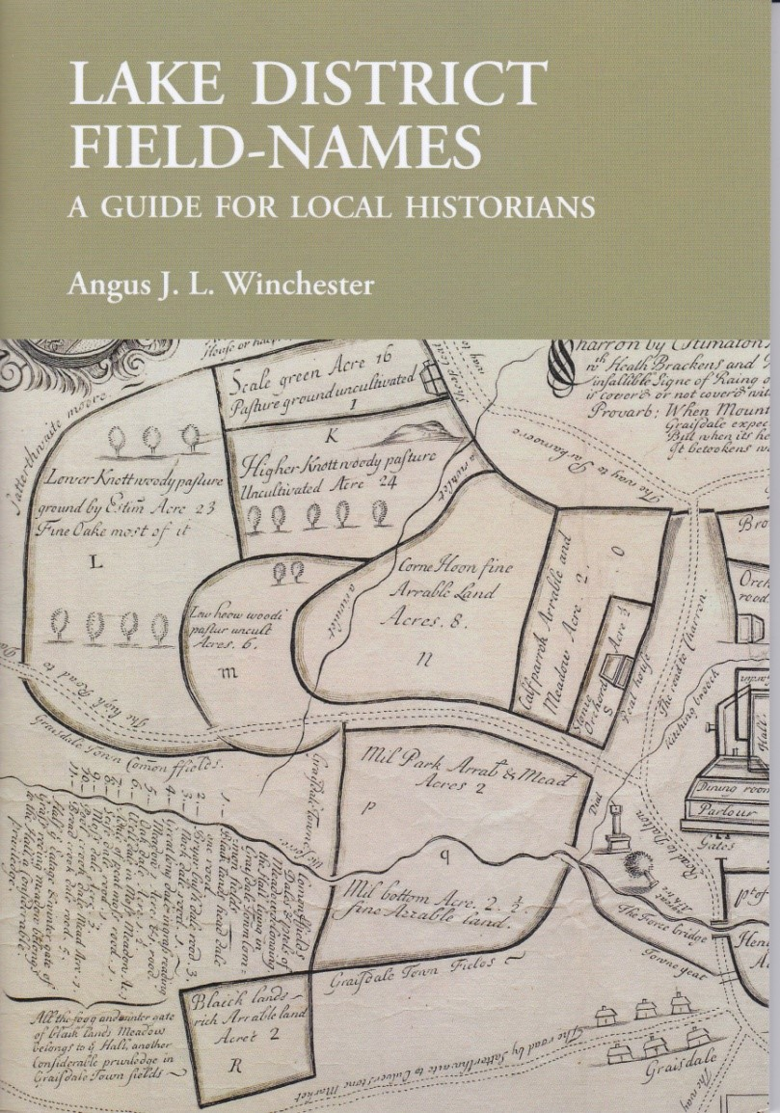While we’re on the subject of the Regional Heritage Centre, they’ve just published Angus Winchester’s Lake District Field-Names. A guide for local historians.
This is a really useful little book, priced at just £4 + £1 for p&p. ‘It offers advice on the sources to consult in order to discover the field-names of a local area and on how to interpret the meaning of field-names …. It also contains a detailed glossary of obsolete and dialect terms encountered in field-names and a series of local maps, to illustrate field-naming patterns in different parts of the Lake District.’

To order, go to:
http://www.lancaster.ac.uk/users/rhc/minibook/Field_Names.htm
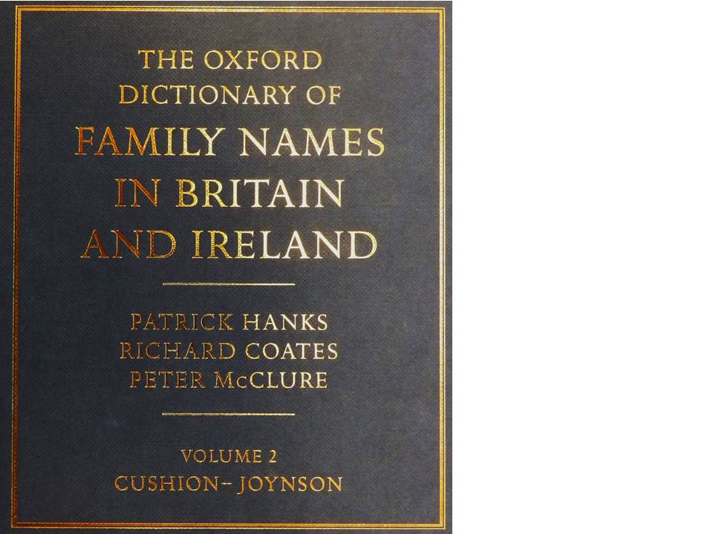Lancashire Archives recently purchased the four-volume Oxford Dictionary of Family Names in Britain and Ireland (edited by Patrick Hanks, Richard Coates, and Peter McClure) – a wonderful resource for family historians. Comprising over 3000 pages, it includes 45,000 surnames and gives their frequency; main GB location; derivation and early references of the name. As examples, here are a couple of familiar Lancashire names:

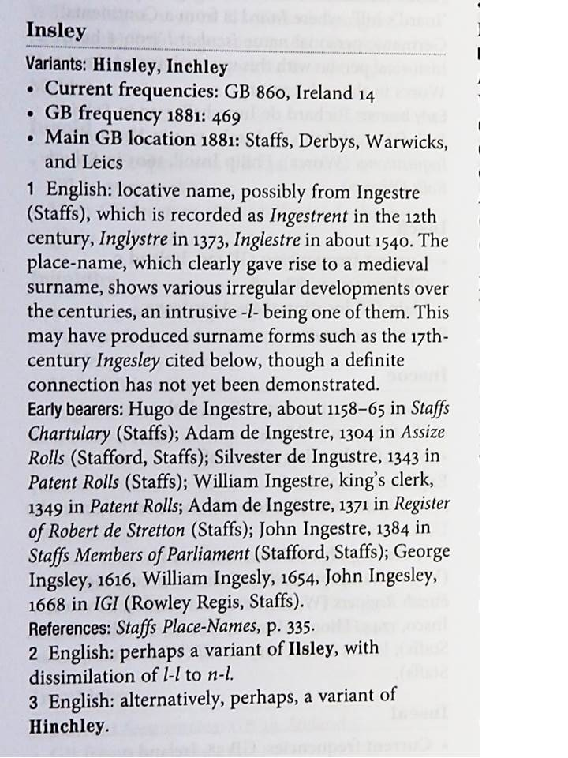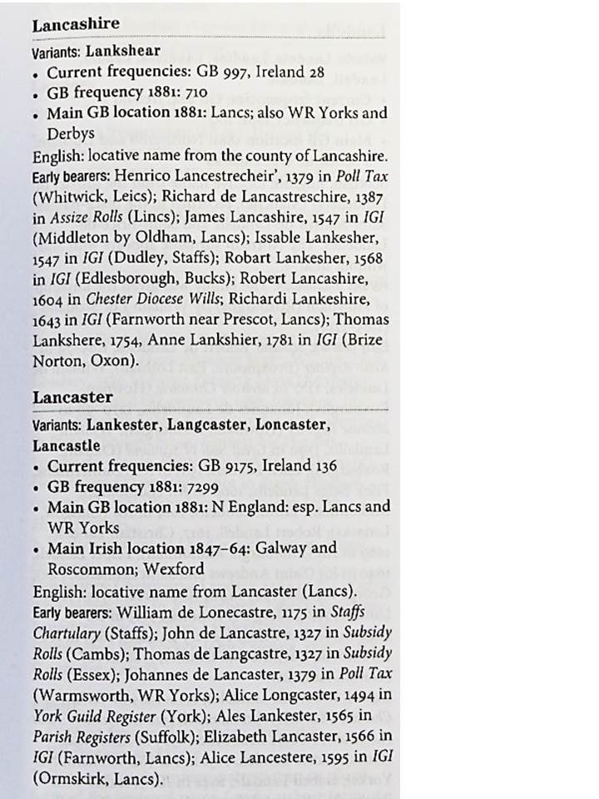

SO, WHERE WAS LOX(H)AM ?
Nigel Neil

A quick Google search for ‘Loxham’ in the Victoria County History (quicker than using my 8- volume set on my bookshelves !), and on the Lancashir Archives’ online catalogue LANCAT, reveals that prominent members of the Loxham family were to be found from the early fourteenth through to the seventeenth centuries in the townships of Longton, Hutton, Preesall with Hackinsall, Howick, Penwortham, and Ainsworth (in Middleton parish, Bolton).

But I have been able to find only two references to the place-name. One is in Longton, where a farm on the OS 1st edition 6 inch to 1 mile map (OS 1847; the name extracted by LPNS volunteers) is called Loxam’s, and this probably relates to a family of that name. The other is more intiguing. An early description of the Roman road (later called Margary 703; Margary 1967, 374-5; OS 1847, sheet 60) from Ribchester to Poulton-le-Fylde mentions Loxham Hill, and appears to place it in the centre of Kirkham, possibly therefore another name for Carr Hill, the hill leading down from the windmill to Dowbridge. Thomas Baines (1868, 239) is describing the road from its (now somewhat questionable) extension of the road West of Kirkham, where we now know there was a fort, towards Preston when he says:

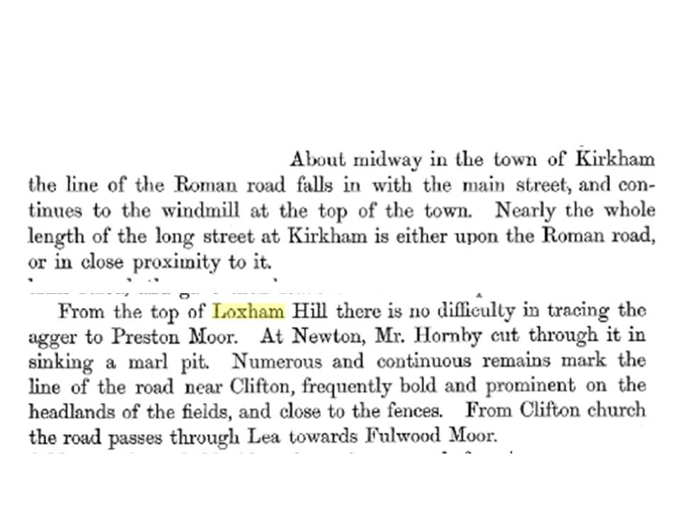

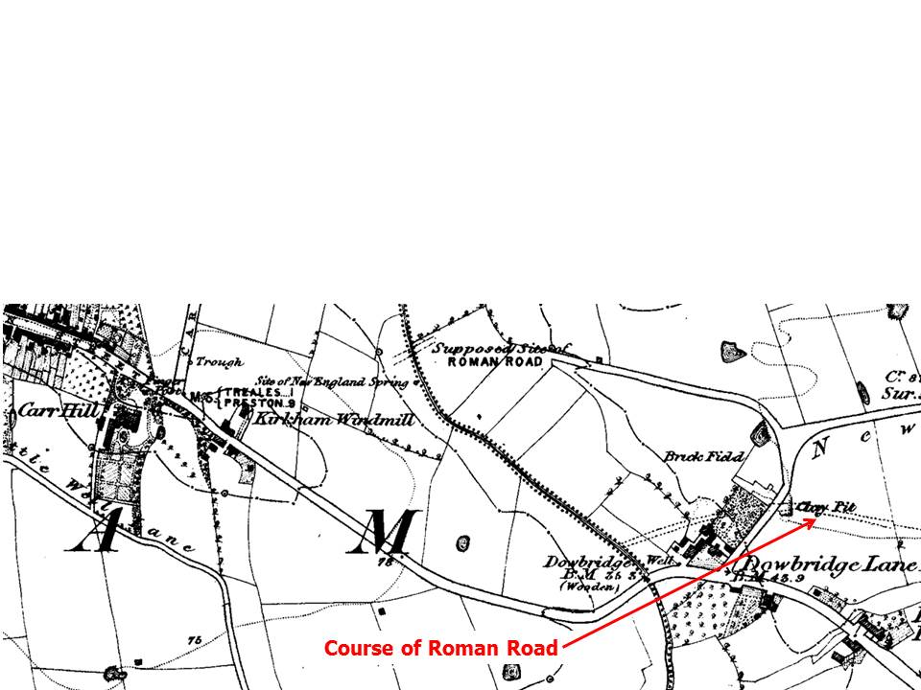This could also be a ‘place named after a person’, since John Loxam of Tarnbrecks, Kirkham, woollen draper, was involved in a ‘pew cause’ in 1741 (Lancashire Archives ARR/2/4/7/72). Unfortunately, none of the earlier or later comentators about the Roman road (e.g. Just 1849; Graystone 1996, 65-6, or Margary himself) mention Loxham Hill, so the jury is still out. ), but it might merit a bit more delving for mentions on Earls of Derby estate maps and the like.

Bibliography
Lancashire Archives, Preston
ARR/2/4/7/72 Archdeaconry of Richmond: Pew Cause Papers: Loxham v all of Kirkham, 1741

Cartographic source
OS, 1847 6”: 1 mile, Lancashire Sheets 60, 68, 1 edn (surveyed 1844), Southampton, Ordnance Survey

Secondary sources
Baines, Thomas, 1868 Lancashire & Cheshire: Past and Present, 1, London: Mackenzie (repr 2012, Heritage Publications)

Graystone, Philip, 1996 Walking Roman roads in The Fylde and Ribble Valley, Centre for North-West Regional Studies, University of Lancaster

Just, John, 1849 The Roman Roads of Lancashire; Part II. On the Seventh Iter of Richard of Cirencester, Trans Historic Soc. Lancashire Cheshire, 3, 3-10

Margary, Ivan D., 1967 Roman roads in Britain, rev edn, London: Baker

